**API** is the acronym for Application Programming Interface

which is a software intermediary (посредник) that allows two applications to talk to each other

*# my comment >> part of the data/app/code that are allowed to use with the API keys (share the info)*

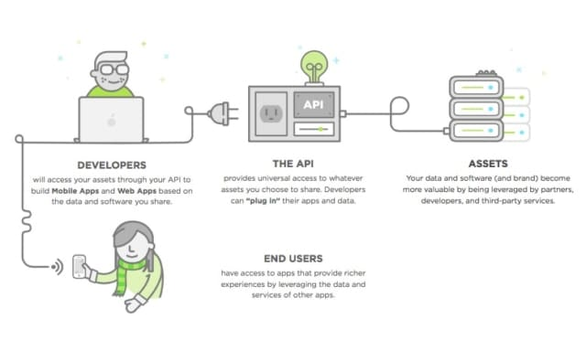

APIs allow software applications to talk to each other, got it. But what are they saying? The language and syntax of APIs limit what you can ask for and get back.

There are four types of API actions:

GET: requests data from a server

POST: sends new information to a server

PUT: makes changes to existing data on a server

DELETE: removes existing information from a server

EXAMPLES

In general, APIs are used to integrate your service or app property with other third-party applications. Why rebuild Twitter to access public user data when you could securely access it somewhere else? Twitter’s API allows developers to access all kinds of profile information, like users’ searches, block lists, real-time tweets, and more – for a variety of use cases.

For example, using the Twitter API you can integrate a Twitter feed into your website or application. Have you ever seen live tweets on a company’s website? There’s an API for that.

REST # my comment >> agreement how API should look like. So developer can follow the rules

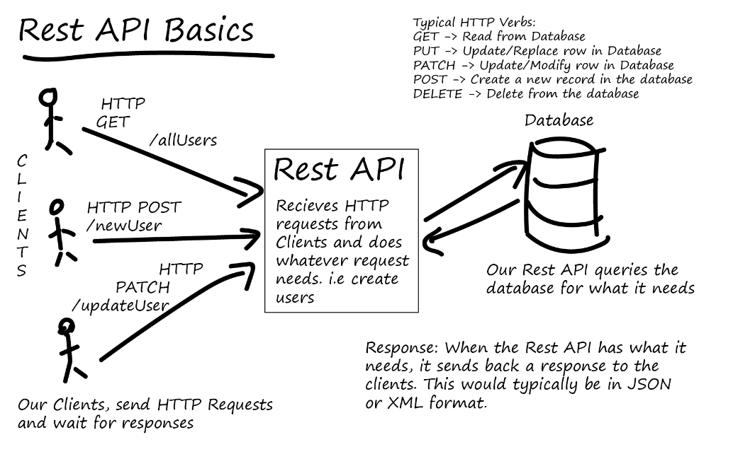

---------------- Json --------------

JSON stands for JavaScript Object Notation

JSON is a lightweight format for storing and transporting data

JSON is often used when data is sent from a server to a web page

JSON is "self-describing" and easy to understand

Json isn’t a language ITS JUST A STRING (with value)

*\*A common use of JSON is to read data from a web server, and display the data in a web page.*

{  
"employees":[  
    {"firstName":"John", "lastName":"Doe"},  
    {"firstName":"Anna", "lastName":"Smith"},  
    {"firstName":"Peter", "lastName":"Jones"}  
]  
}